SEED PROPAGATION OF COLCHICUM CAPENSE SUBSP. CILIOLATUM

Seiichi Fukai^{1*}, Yasuhiro Monden¹, Takako Narumi¹ and Eiichi Kodaira²

¹Horticultural Science, Faculty of Agriculture, Kagawa University, Miki-cho, Kagawa 761-0795, Japan
²Takeda Garden for Medicinal Plant Conservation, Ichijoji, Sakyo-ku, Kyoto 606-8134, Japan
*E-mail: fukai@ag.kagawa-u.ac.jp *Fax: +81-87-891-3072

Abstract
Colchicum capense subsp. ciliolatum native to South Africa have high ornamental values as a new pot plant. The species produced seeds by both self-crossings and out-crossings, indicating that the species is self-compatible. Stable seed production was achieved by hand pollination. Optimum temperature for seed germination was 15°C. The germination was suppressed completely at temperatures higher than 20°C. Seeds were dormant immediately after harvest and the dormancy broke after three months’ dry storage, irrespective of the storage temperature conditions. GA₃ did not affect seed germination at 25°C. Fluridone treatment restores seed germination at 25°C, but the germination remained less vigorous than germination at 15°C. Seeds incubated at 25°C for 1–2 weeks before transfer to 15°C showed poor germination. However, seeds treated with fluridone germinated well irrespective of the 25°C incubation term. Results suggest that abscisic acid causes thermoinhibition in this species. Application of fluridone and GA₃ slightly enhanced seed germination, but when endogenous gibberellin biosynthesis was suppressed with uniconazole treatment, the seeds did not germinate even though fluridone was administered at 25°C. Seedlings from seeds and one-year old corms produced a new corm as a dropper. Three years are necessary to produce flowering-sized corms of this species. Present results showed a possibility to horticultural use of this species.

Key words: Androcymbium, dormancy, fluridon, germination, gibberellin, thermoinhibition

Running title: Seed germination of Colchicum capense subsp. ciliolatum

INTRODUCTION
Colchicum capense subsp. ciliolatum (syn. Androcymbium ciliolatum) is native to the Northern Cape and Western Cape in South Africa. A group of species in Colchicum native to southern Africa was classified earlier in the genus Androcymbium. Recent taxonomy based on DNA sequences of three plastid regions has suggested a new definition of the genus Colchicum including Androcymbium (Manning et al. 2007, Vinnersten and Reeves 2003). To avoid confusion, the newer and wider definition of the genus Colchicum is used for this study.
C. capense subsp. ciliolatum produce inflorescence consisting of about 10 flowers and bracts. Several bracts of lower positions develop well and display white, producing its ornamental value. As implied by the English common name ‘Cup and Saucer’, the incurved bracts are arranged alternately producing a cup shape. Flowering of C. capense subsp. ciliolatum occurs during winter in greenhouses without heating in Japan. From the characteristics of the flower and flowering time, the species is promising as a new pot plant in winter.
Corms of C. capense subsp. ciliolatum produce only two daughter bulbs without cormel production in a growing season, resulting in low propagation efficiency. Therefore, establishment of seed propagation of the species is necessary for commercial pot plant production. However, seed production of C. capense subsp. ciliolatum has not been recorded in Japan. Furthermore, no germination physiology of C. capense subsp. ciliolatum has ever been reported. Only some fragmented information related to seed germination of genus Colchicum is available (Baskin and Baskin, 1998).
The aims of this study are to reveal seed germination and to establish corm production of C. capense subsp. ciliolatum. In this study, seed production, optimum conditions for seed germination and seedling production of C. capense subsp. ciliolatum were investigated.

Materials and Methods
Seed production
Corms of C. capense subsp. ciliolatum were planted in plastic containers with Masa soil (granite soil) and manure (3:1[v/v]) in October. Then they were grown in a greenhouse without heating (an example of average max./min. temperatures (2011-2012) : 31.2/14.4°C in Oct., 25.4/8.8°C in Nov., 19.4/2.8°C in Dec., 22.9/0.3°C in Jan., 26.5/1.3°C in Feb, 31.7/5.8°C in Mar., 32.0/ 10.2°C in Apr., a latitude of 43 degree north). The plants flowered from mid-January to February. Both self-crossings and out-crossings were done using paint brushes. Some other flowers were left without hand-pollination. To avoid pollination between cloned plants, individuals having different pistil and anther color were carefully chosen in out-crossings.
Capsules were harvested and air-dried at room temperature in early May. Seeds were removed from the capsules and empty seeds were discarded. Numbers of seeds in a capsule and seed weight were recorded. The seeds were stored in dry conditions at room temperature until further use, except in Exp. II.

Germination experiments
Seeds were placed on four layers of tissue paper that had been moistened with distilled water in a plastic Petri dish. Appearance of the radicle was defined as seed germination. It was confirmed that the radicle emerged seeds developed to seedlings. Each treatment consisted of three replications with 50 seeds.
Experiment I. Seeds were incubated at various temperatures (10, 15, 20, 25, and 30°C) under dark conditions respectively in late September, October, November, and December.
Experiment II Seeds were stored at 20°C or 30°C in dry conditions for 0, 1, 2, 3, or 4 months from late May. Then the seeds were incubated at 15°C under dark conditions.
Experiment III. Seeds were soaked in 50, 100, 500, or 1000 mg l⁻¹ GA₃ (Meiji Seika Kaisha Ltd., Tokyo) for 16 hr at room temperature and were then incubated at 15°C or 25°C under dark conditions in September.
Experiment IV. Seeds were placed on moistened tissue paper and incubated at 25°C for a week or two weeks with or without 1 mg/l fluridon (Sigma-Aldrich); then they were transferred to 15°C under dark conditions in October.
Another group of seeds was soaked in 1 mg l⁻¹ fluridon, 1 mg l⁻¹ fluridon+100 mg l⁻¹ GA₃, 1 mg l⁻¹ fluridon+10 mg l⁻¹ uniconazole P (Sumitomo Chemical Co. Ltd.) or water for 16 hr at room temperature and then incubated at 25°C under dark conditions in October.

Growth and development of seedlings
Seeds were sown in seed trays with growing mix (Metro-Mix 350; Sun Gro Horticulture Canada CM Ltd.) and were placed in a greenhouse without heating in late September. Corms were harvested after leaf die-back in May, dried for some weeks at room temperature, and weighed. One-year-old and two-year-old corms were planted in plastic containers again in October.

Statistic analysis
Germination was evaluated by days to 50% germination and final germination percent. Statistical analysis of germination percentage (after arcsine transition) was performed using Tukey’s multiple range test. Number of seeds and seed weight were compared with t-test.

Results and Discussion

- Seed production
C. capense subsp. ciliolatum flowered in January–February in the non-heated greenhouse. The inflorescence consisted of about 10 florets, some lower position of florets developed capsules. The peduncle of inflorescences grew up in April; then the capsules were harvested and dried. The capsule had three compartments. The seeds of C. capense subsp. ciliolatum had a well-developed raphe in a caruncula (Fig. 1 A), as observed in other species in Colchicum (Androcynbium) (Membrives et al., 2003).
No fruit set was observed in flowers without hand pollination, although hand-pollinated flowers produced seeds whether self-pollinated or out-pollinated (Table 1). No difference was found in the average seed weight or the number of seeds per pods. Seeds derived from both self-pollination and out-pollination showed same germination ability (data not shown). The results indicate that a lack of pollinators in a greenhouse is the main reason for rare seed production of C. capense subsp. ciliolatum in Japan. Results also demonstrated that the species is self-compatible. Kleizen et al. (2008) reported that some Colchicum species in southern Africa are rodent-pollinated, and that C. scabromarginatum is self-incompatible but C. coloratum is partially self-compatible. The breeding system of C. capense subsp. ciliolatum in its habitat has not been reported yet, but present results demonstrate that stable seed production of this species can be achieved by hand pollination.

- Optimum temperature for seed germination
Seed germination of C. capense subsp. ciliolatum was observed only at 10° and 15°C, but not at temperatures higher than 20°C. Germination started from 25 days after sowing (DAS) and reached maximum (80%) up to 50 DAS at 15°C, although it was started at 45 DAS and remains at a low level at two months later at 10°C (Fig. 2). The same responses to temperature in seed germination were observed during August–December, indicating that the range of temperature for seed germination did not change. Present results show that the suitable temperature range for seed germination of C. capense subsp. ciliolatum is rather low as temperate plants. The low optimal temperature for seed germination of Colchicum (Androcynbium) has already been described by Baskin and Baskin (1998), but its ecological meaning remains unclear. The preference for low temperature for germination in this species is similar to that of many Mediterranean plants. The results suggest that the high temperature of summer in Japan depresses the seed germination of C. capense subsp. ciliolatum.

- Effects of storage temperature on seed germination
Seeds incubated at 15°C in late May in 2008 (immediately after harvest) showed poor and slow germination (Fig. 3). Lower germination was also observed in seeds stored for 1–2 months, irrespective of storage temperature (20–30°C) conditions. Seeds stored for more than 3 months showed significantly higher germination irrespective of storage temperature conditions. Results show that seeds of C. capense subsp. ciliolatum are dormant immediately after harvest and that the dormancy breaks after about three months of dry storage. The seed germination of C. capense subsp. ciliolatum might be classified as non-deep physiological dormancy type 5 according to Baskin and Baskin (2004). The results also show the possibility of morphological or morphophysiological dormancy of this species, i.e., the embryo is premature at harvest and develops during storage.
When seeds of C. capense subsp. ciliolatum were sown in soil in a greenhouse during summer, germination was observed in November in Japan. The germination time might be determined both by times of breaking dormancy and temperature drop to the suitable temperature for seed germination in November.

- Effects of GA₃ on seed germination
No seed germination was observed at 25°C even though various concentration of GA₃ was applied to the seeds (Fig. 4). All seeds germinated well at 15°C; no significant difference was found in either the number of days to 50% germination or the final germination percentage. This experiment was done in September when the seed dormancy of this species had already broken, suggesting that high temperatures suppressed seed germination and that it is not related to dormancy. High temperatures suppress the seed germination in some plants. Suppression at the supra-optimal temperature is called thermoinhibition. Abscisic acid (ABA) involves suppression in lettuce (Yoshioka et al., 1998, Gonai et al., 2004) and Arabidopsis (Toh et al., 2008). Present results show that GA₃ was ineffective at restoring seed germination of C. capense subsp. ciliolatum at 25°C.

- Effect of fluridone on seed germination
Seeds incubated at 25°C for 1–2 weeks before transfer to 15°C showed poor germination (Fig. 5). However, seeds treated with fluridone germinated about 3 weeks after incubation, irrespective of the 25°C incubation term.
Present results indicate that ABA involves the thermoinhibition of seed germination in C. capense subsp. ciliolatum. The poor germination of seeds exposed to 25°C for 1 or 2 weeks before incubation at 15°C suggests that ABA was synthesized immediately at 25°C. Once ABA was synthesized, the germination was suppressed despite suitable temperature conditions. Fluridone is known to depress endogenous biosynthesis of ABA (Yoshioka et al., 1998). Present results demonstrated that fluridone-treated seeds germinated as if the seeds had been incubated at 15°C from the start of incubation, indicating that accumulation of ABA is the main reason for thermoinhibition in this species.
Seeds treated with fluridone started to germinate on 30 DAS and showed vigorous germination from 50 DAS at 25°C, whereas control seeds did not germinate at all (Fig. 6). When seeds were treated with both GA₃ and fluridone, their early germination was enhanced slightly and vigorous germination was observed during the same period as the seeds treated with fluridone. However, seeds treated with both uniconazole and fluridone did not germinate at all.
These results showed that fluridone treatment restores seed germination of C. capense subsp. ciliolatum at 25°C, but the germination remained less vigorous compared to germination at 15°C. The application of fluridone and GA₃ slightly enhanced seed germination while the promoting effect on germination at 25°C was not observed when gibberellin was solely treated with various concentrations (Fig. 4). In lettuce seeds, only a combined application of GA₃ and fluridone brought high germination at 33°C (Gonai et al., 2004). The results showed that GA₃ also worked to reduce ABA levels in lettuce seeds, as demonstrated by the fact that exogenous GA₁ decreased expression level of ABA biosynthesis related gene (Sawada et al., 2008). However, when endogenous gibberellin biosynthesis was suppressed with uniconazole treatment, the seeds did not germinate, even though fluridone was treated as described in lettuce (Endo et al., 2001). Saito et al. (2003) have revealed that uniconazole not only inhibits GA biosynthesis, but also ABA catabolism in Arabidopsis. These facts suggest that endogenous GA biosynthesis is necessary to germinate and that GA does not work, or might suggest that sensitivity to GA was lowered when ABA had existed in seeds of this species.

- Growth and development of seedlings
Seedlings from seeds and one-year-old corms produced a new corm as a dropper (Figs. 1B, 1C). The dropper type of bulb formation is widely observed in bulbs that are native to arid climates. Mature corms of C. capense subsp. ciliolatum produced two daughter corms, as described by Membrives et al. (2002), but the small corms produced a single daughter corm per year.
The weight of a corm from seed was 18 mg, on average, in the first year. The one-year old corms developed corms in a range of less than 100 mg to more than 500 mg (av. 251 mg, n = 80) in the second year (Fig. 7). Only 2.1% of 200–300 mg two-year-old corms flowered in the following season. Fukai et al. (in press) reported that more than 5 g corms C. capense subsp. ciliolatum showed 100% conversion to reproductive phase. Therefore, at least three years are necessary to produce flowering sized corms of C. capense subsp. ciliolatum.

Present study has revealed the conditions of the stable seed production and germination of C. capense subsp. ciliolatum. The results have opened a possibility to horticultural use of this species.

REFERENCES

Baskin C. C., Baskin J. M. (1998). Seeds. pp. 55. Academic Press. San Diego.
Baskin J. M., Baskin C. C. (2004). A classification system for seed dormancy. Seed Science Research, 14: 1-16.
Endo T., Yoshitake T., Gonai T., Satoh S., Hashiba T. (2001). Induction on seed germination at high temperatures by herbicides which inhibit carotinoids biosynthesis. Tohoku Weed Journal, 1: 3-6. (in Japanese)
Fukai S., Monden Y., Narumi T., Kodaira E. Flowering control of Colchicum capense subsp. ciliolatum. Acta Horticulturae, (in press).
Gonai T., Kawahara S., Tougou M., Satoh S., Hashiba T., Hirai N., Kawaide H., Kamiya Y., Yoshioka T. (2004). Abscisic acid in the thermoinhibition of lettuce seed germination and enhancement of its catabolism by gibberellin. Journal of Experimental Botany, 55: 111-118.
Kleizen C., Midgley J., Johnson S. D. (2008). Pollination systems of Colchicum (Colchicaceae) in southern Africa: Evidence for rodent pollination. Annals of Botany, 102: 747-755.
Manning J., Forest F., Vinnersten A. (2007). The genus Colchicum L. redefined to include Androcymbium Willd. based on molecular evidence. Taxon, 56: 872-882.
Membrives N., Caujape`-Castells J., Ardanuy A., Pedrola-Monfort J. (2002). Reproductive biology of the genus Androcymbium (Colchicaceae) in western southern Africa. Orsis, 17: 37-59.
Membrives N., Pedrola-Monfort J., Caujape`-Castells J. (2003). Morphological seed studies of southwest African Androcymbium (Colchicaceae). Botanical Macarone`scia, 24: 87-106.
Sawada Y., Aoki M, Nakaminami K, Mitsuhashi W, Tatematsu K, Kushiro T, Koshiba T, Kamiya Y, Inoue Y, Nambara E, Toyamasu T. (2008). Phytochrome- and gibberellin-mediated regulation of abscisic acid metabolism during germination of phytoblastic lettuce seeds. Plant Physiology, 146: 1386-1396.
Saito, S., Okamoto M., Shinoda S., Kushiro T., Koshiba T., Kamiya Y., Hirai N., Todoroki Y., Sakata K., Nambara E., Mizutani M. (2006). A plant growth retardant, uniconazole, is a potent inhibitor of ABA catabolism in Arabidopsis. Bioscience, Biotechnology, and Biochemistry, 70: 1731-1739.
Toh S., Imamura A., Watanabe A., Nakabayashi K., Okamoto M., Jikumura Y., Hanada A., Asao Y., Ishiyama K., Tanura N., Iuchi S., Kobayashi M., Yamaguchi S., Kamiya Y., Nambara E., Kawakami N. (2008). High temperature-induced abscisic acid biosynthesis and its role in the inhibition of gibberellin action in Arabidopsis seeds. Plant Physiology, 146: 1368-1385.
Yoshioka T., Endo T., Satoh S. (1998). Restoration of seed germination at supraoptimal temperatures by fluridone, an inhibitor of abscisic acid biosynthesis. Plant Cell Physiology, 39: 307-312.
Vinnersten A and G Reeves. (2003). Phylogenetic relationships within Colchicaceae. American Journal of Botany, 90: 1455-1462.

Table 1 Seed production by hand pollination
 | n | No. capsules with seeds | Avg. seed number per capsule | 100 seed weight (mg)
No hand pollination | 10 | 0 | 0 | -
Hand pollination (self) | 10 | 10 | 138.7 ± 19.4 | 167.0 ± 4.1
Hand pollination (out) | 10 | 10 | 142.3 ± 19.7 | 173.5 ± 4.6
t-test |  |  | n.s. | n.s.
t-test was performed between self- and out-crossings.
n.s.: not significant

Fig. 1 Capsule, seeds and young corms of C. capense subsp. ciliolatum.
A: Capsule and seeds. Arrow indicates a raphe. bar = 5 mm
B: Corms from seeds. Arrows indicate the seed position. Bar = 1 cm
C: Corms from 1-year-old corms. Arrows indicate the old corm position. Bar = 1 cm

Fig. 2 Optimal temperature for seed germination of C. capense subsp. ciliolatum.
Seeds were placed on moistened paper and kept at 10–30°C. This test was done in late September.
Data of 30°C were omitted from the graph because no germination was observed at temperatures higher than 20°C. Different letters indicate a significant difference (P<0.05) based on Tukey’s test in germination percentage.

Fig. 3 Effects of storage temperature on seed germination.
Seeds were stored at 20 or 30°C in dry conditions for 0, 1, 2, 3, or 4 months from late May. Then the seeds were incubated at 15°C. Cont. means sowing just after seed harvest. Different letters indicate a significant difference (P<0.05) based on Tukey’s test in germination percentage.

Fig. 4 Effects of GA₃ on seed germination.
Seeds were treated with 50, 100, 500, or 1000 mg/L GA₃ for 16 hr and were then incubated at 25 or 15°C. Since no germination was observed at 25°C a symbol (X) represents all GA treatments at 25°C. n.s.: not significant

Fig. 5 Effect of exposure time to 25°C and fluridon on seed germination.
Seeds were incubated at 25°C for a week (1W25) or two weeks (2W25) with (F) or without fluridon. They were then transferred to 15°C. Different letters indicate a significant difference (P<0.05) based on Tukey’s test in germination percentage.

Fig. 6 Effects of fluridone, GA and uniconazole on seed germination.
Seeds were treated with fluridon (F), fluridon+GA₃(FG), fluridon+ uniconazole (FU) or water (C) for 16 hr before incubation at 25°C. Different letters indicate a significant difference (P<0.05) based on Tukey’s test in germination percentage.

Fig. 7 Size variations of the two-year old corms
Average weight of the corms was 250 mg (n = 80).
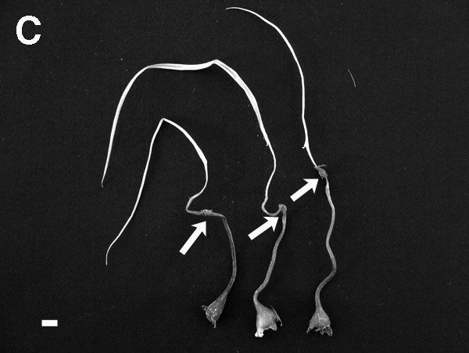
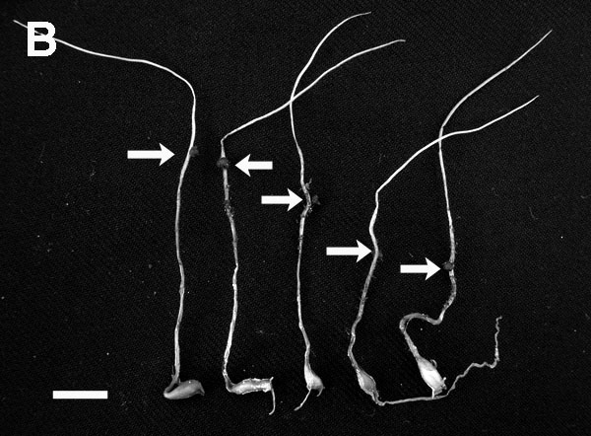
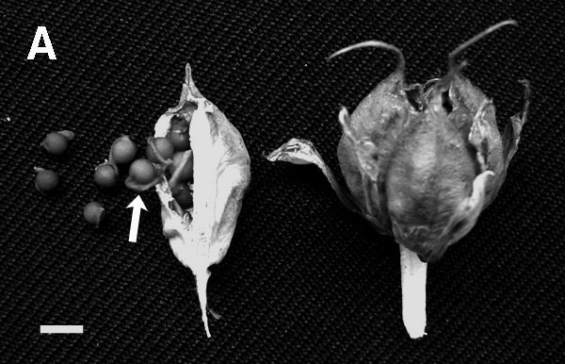
Fig.1 Fukai et al.

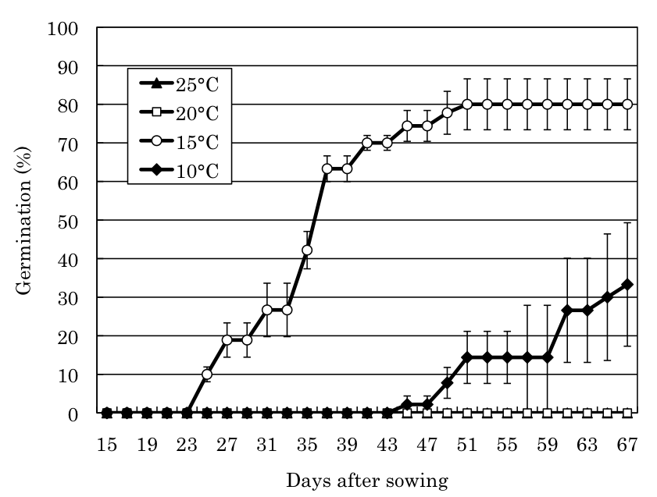
a
b
c

Fig.2
Fukai et al.

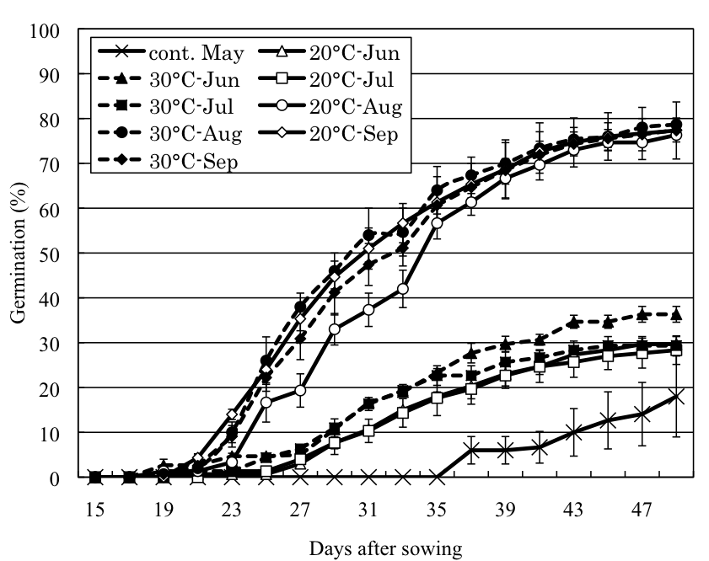
a
a
a
a
b
b
b
b
b

Fig.3
Fukai et al.

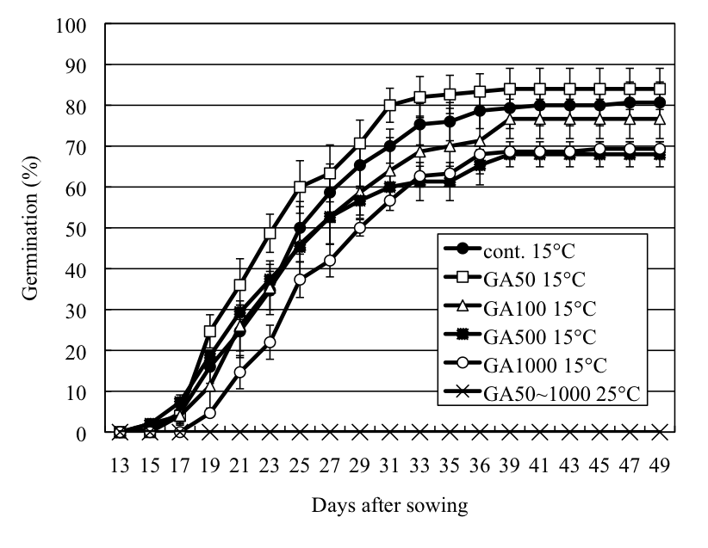
n.s.

Fig.4
Fukai et al.

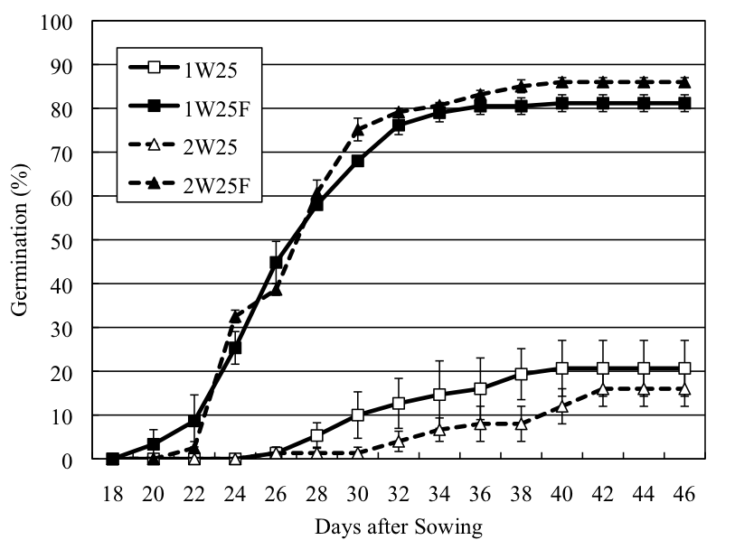
a
a
b
b

Fig. 5
Fukai et al.

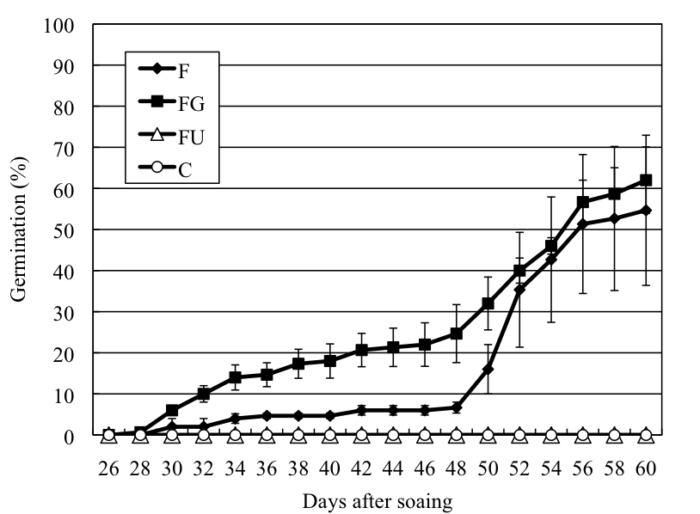
b
b
a
a

Fig.6
Fukai et al.

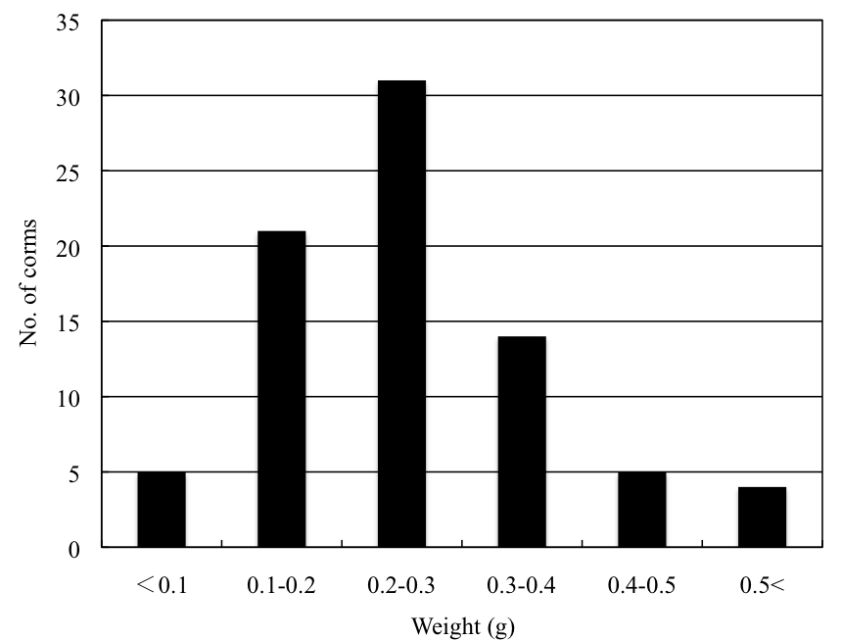

Fukai et al.
Fig. 7

